Various ways to Communicate Via SportsEngine:
Login to SportsEngine, Choose Members, then Directory. On the Right side there is a Message button
Choose who you want to message [a team, an individual (s) on a team, a Group, etc] Click the Box(es) , Click the Message button and the Email window appears, enter the message and click Send
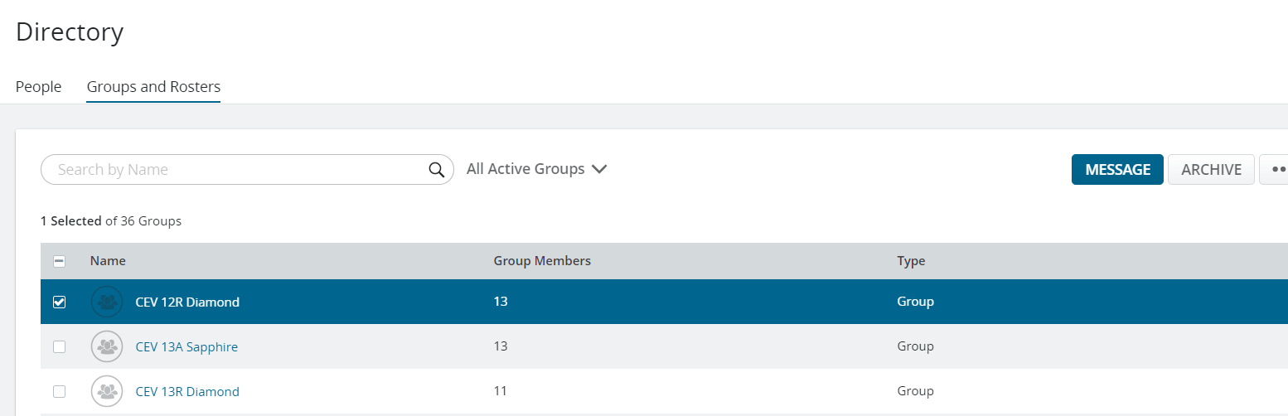
OR
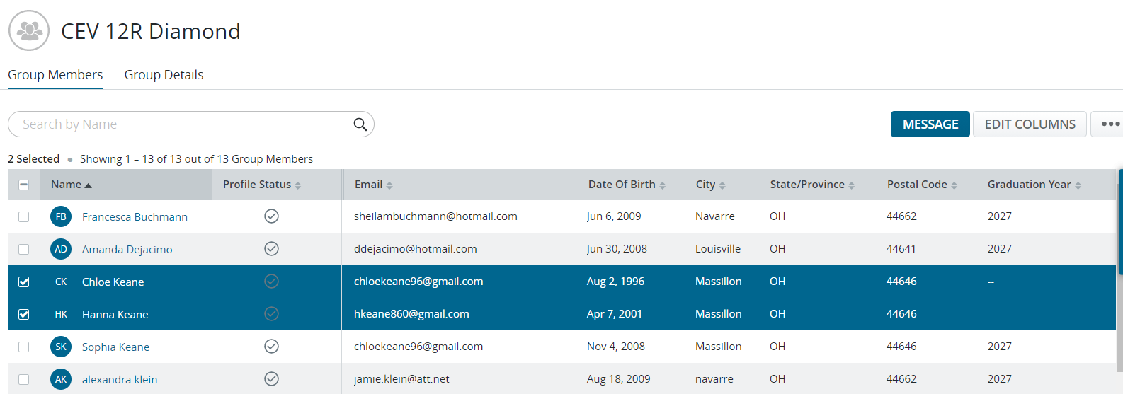
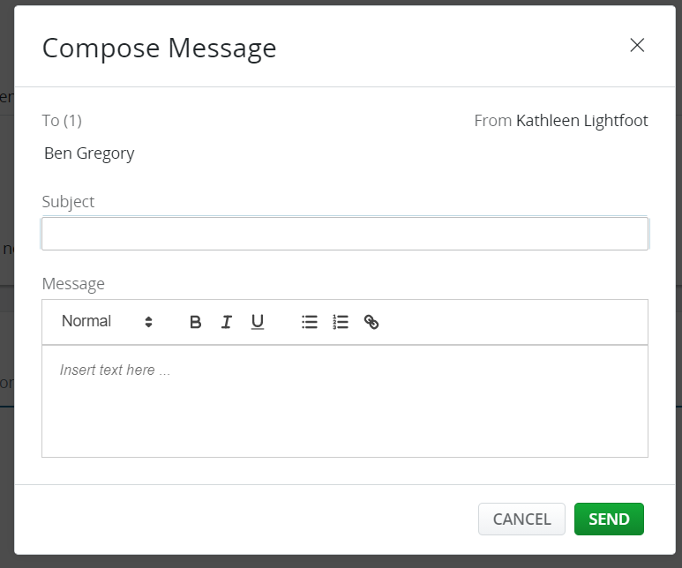
Chloe Keane, Hanna Keane

B: Reminders
Login to SportsEngine, Choose Governing Season, Click on Memberships, click on the 3-Dots next to the Memberships you need to send reminders. Click on View Ineligible and those that are ineligible members window appears, either click the individuals check box or if you want to select all, choose the Check box next to “Name”. On the Left side of the page Send Reminders is highlighted once a member is chosen. Click Send Reminders and the reminder is sent.
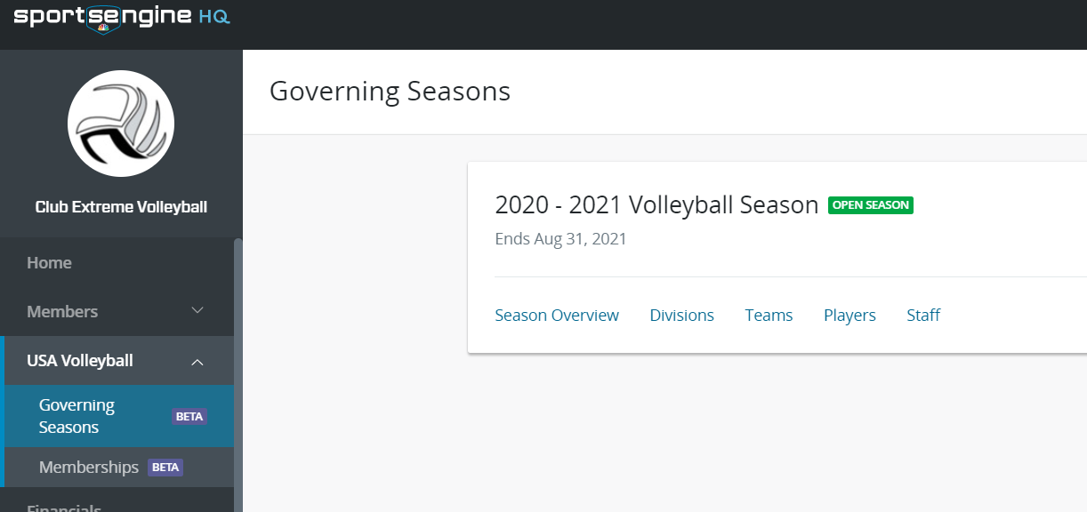
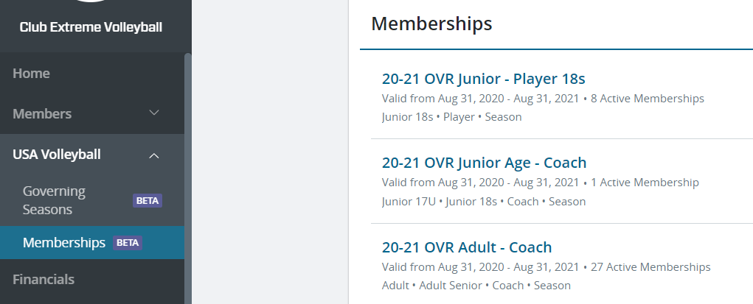

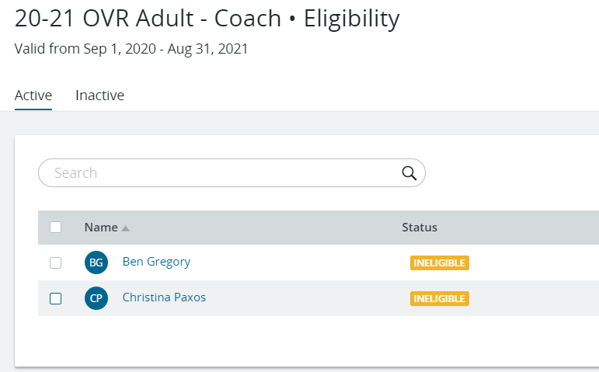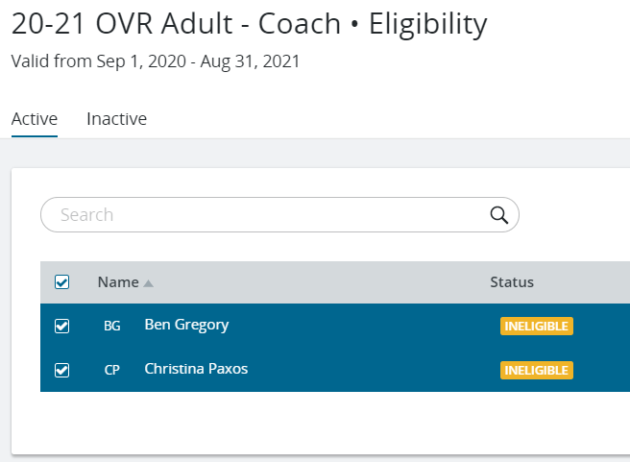
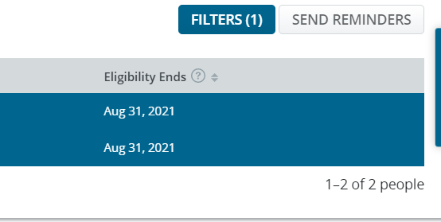
Should you be in Governing Seasons: Choose USA Volleyball, then Governing Seasons, click on Teams-Players or Staff. Look for those that show incomplete and then click on a Name of the person to send the message to. A new window will pop up. Scroll down in the pop-up window to find View Profile.
